FOR IMMEDIATE RELEASE University Settlement
February 16, 2024 4800 Broadway Ave.
Cleveland, OH 44127

University Settlement Announces a New Leader

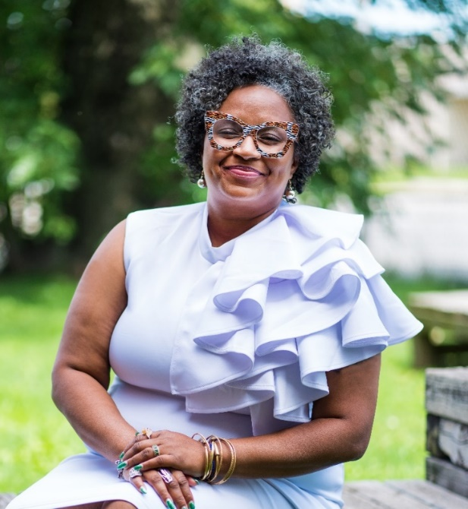
The University Settlement Board of Directors is excited to announce the appointment of Richaun N. Bunton, LSW, MSW, as the new Executive Director of University Settlement. She will begin her formal duties March 11. Earl Pike, University Settlement’s current Executive Director, will be stepping down March 8, and is assisting with the transition.
Ms. Bunton most recently served as VP of Community Engagement at the St. Vincent Charity Health Campus, and as Managing Director of the Cleveland Central Promise Neighborhood at the Sisters of Charity Foundation. Previously, she worked as the FACE Program Manager for the Cleveland Metropolitan School District. She is a graduate of the Cleveland Leadership Center’s Bridge Builder program (class of 2020) and of the Neighborhood Leadership Institute (Class 29) and was elected to the boards of directors of Intergenerational Schools, and of Pregnant with Possibilities. Ms. Bunton herself is the proud mom of seven children.
A resident of nearby Garfield Heights, Ms. Bunton is deeply familiar with Slavic Village, having grown up near 93rd and Bessemer – “the Village” has long been her home. “I’m thrilled to join University Settlement’s team, and to continue to grow the vision of service, growth, equity, justice, and engagement. The Settlement has an amazing staff, and the community is blessed with so many active, caring people. I can’t wait to get started.”
Percival Kane, the President of University Settlement’s board of directors, echoed that excitement. “We’re thrilled Ms. Bunton will be bringing her talents and skills to our agency. She’s just the right person to build off the successes of the Broadway Rising campaign, and further develop capacity and community. We couldn’t have made a better choice.” Board Vice-President Carrie Miller, who lives in Slavic Village, expressed a similar sentiment: “The combination of deep community knowledge and history, and demonstrated expertise in many areas, makes her the right choice for all of us.”

Established in 1926, University Settlement is the oldest and largest social service agency in Slavic Village, also serving Parma and 14 other zip codes. In 2023 along, University Settlement provided services to 13,100 of Slavic Village’s 22,000 residents (60%, unduplicated). Services include nearly 250,000 meals, afterschool and in-school youth support, senior services, family programs, housing assistance, HIV outreach, alcohol and drug abuse prevention, workforce development, health promotion, and more.
####

